Cecile I. (Grover) Hunnicutt-Scott
June 15, 1906 – June 6, 1972

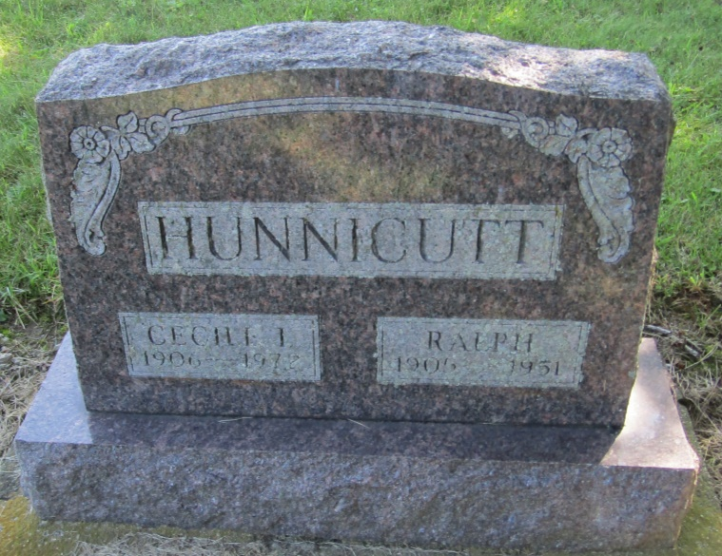

Cecile Scott
in the Indiana, Death Certificates, 1899-2011
Name: Cecile Scott
[Cecile Grover]
Gender: Female
Race: White
Age: 65
Marital status: Married
Birth Date: 15 Jun 1906
Birth Place: Indiana
Death Date: 6 Jun 1972
Death Place: Bluffton, Wells, Indiana, USA
Father: Robert Grover
Mother: Susanah Mossburg
Spouse: Ross Scott
Informant: Mrs. Marjorie Collins; daughter; Bluffton, Indiana
Burial: June 8, 1972; Mossburg Cemetery; Liberty Center, Indiana

