Gay Lynn (Walker) Huffman
August 9, 1945 – October 13, 2000

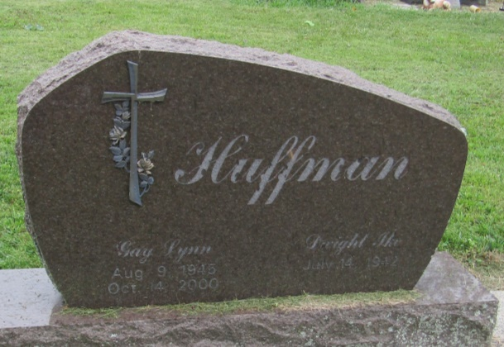

Gay Lynn Huffman, 55
Gay Lynn Huffman, 55, who resided in Wells County on a Huntington rural route, was injured fatally in an auto accident on St. Rd. 124 at 7:40 p.m. Saturday. She had been employed since 1982 in the pharmaceutical department of Peyton Northern Distribution Center west of Bluffton. Born in Fort Wayne, Mrs. Huffman had resided in Wells County all of her life. She was a member of Boehmer United Methodist Church.
She was born Aug. 9, 1945 to Lewis J. and Juanita Morgan Walker. Her marriage at Ossian on Oct. 19, 1963 was to Dwight Ike Huffman, who survives. Her mother also survives and resides in Ossian.
Surviving also are three sons, Brent of Bluffton, Greg of Poneto and Matt of Fort Wayne; two brothers, Donald Walker of Bluffton and Gary Walker of Fort Wayne; a sister, Mrs. John (Donna) Freds of Huntington; and six grandsons.
Services will be held at 10:30 a.m. Wednesday at Thoma/Rich, Hewitt & Chaney Funeral Home with Rev. Barry Humble officiating. Burial will be in Mossburg Cemetery at Liberty Center. Calling hours at the funeral home will be Tuesday from 1 to 9 p.m.
Memorials to Boehmer United Methodist Church or to the American Diabetes Association.

Bluffton News-Banner, Wells County, Indiana
Monday, October 15, 2000

