Lucretia Ellen (Helton) Householder
April 28, 1882 -

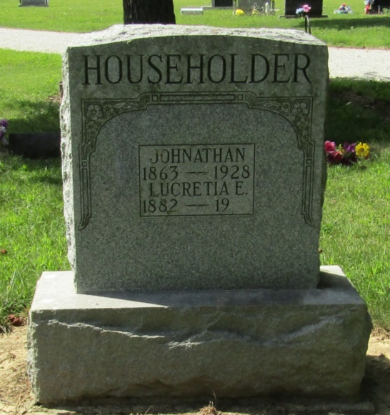

Indiana, Marriage Index, 1800-1941

Name: Lucresa Helton
Spouse Name: James A. Huston
Marriage Date: 13 Jan 1900
Marriage County: Wells
*****

Indiana, Marriages, 1810-2001

Name: Lucretia Ellen Huston
[Lucretia Ellen Helton]
Gender: Female
Race: White
Age: 28
Event Type: Marriage Registration (Marriage)
Birth Date: 28 Apr 1882
Birth Place: Wells, Indiana
Marriage Date: 21 Mar 1911
Marriage Place: Indiana, United States
Residence Place: Wells, Indiana
Father: Hiram C Helton
Mother: EMa E Mcelhaney
Spouse: John Householder
Page: 11; FHL Film Number: 002318675

