Caroline (McFarren) Hinkle
October 1, 1834 – December 16, 1917

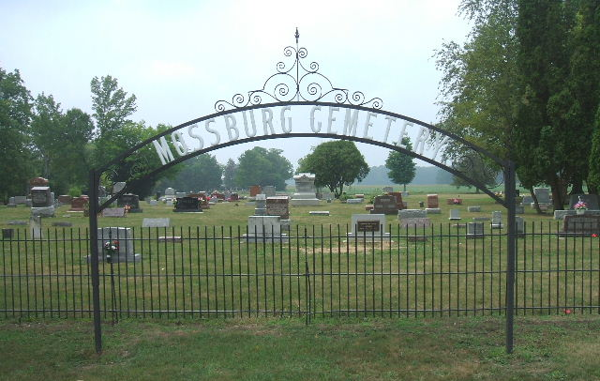
Photo by Tombstoner & Family

Caroline Hinkle
in the Indiana, Death Certificates, 1899-2011
Name: Caroline Hinkle
[Caroline McFarren]
Gender: Female
Race: White
Age: 83
Marital status: Widow
Birth Date: 1 Oct 1834
Birth Place: Ohio
Death Date: 16 Dec 1917
Death Place: Salamonie, Huntington, Indiana , USA
Father: Adam McFarren
Mother: Elizabeth Chapman
Spouse: Samuel Hinkle
Informant: Mrs. Wm. Ware
Burial: December 18, 1917; Mossburg Cemetery

