Glen R. Highlen
June 4, 1898 – March 16, 1963

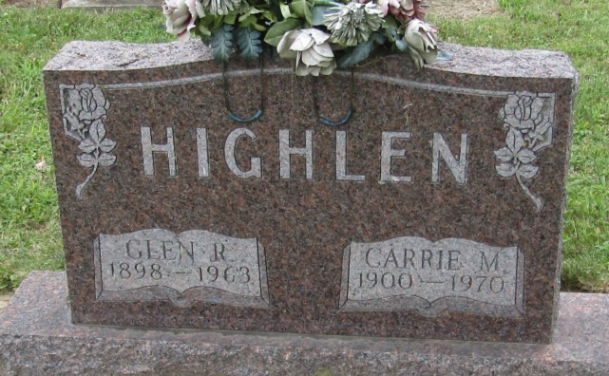

Glen R Highlen
in the Indiana, Death Certificates, 1899-2011
Name: Glen R Highlen
Gender: Male
Race: White
Age: 64
Marital status: Married
Birth Date: 4 Jun 1898
Birth Place: Wells Co, Ind
Death Date: 16 Mar 1963
Death Place: Rural, Wayne, Indiana , USA
Father: Frank Highlen
Mother: Sarah Redding
Informant: Richmond State Hosp. Records; Richmond, Indiana
Burial: March 19, 1963; Mossburg Cemetery; Wells County, Indiana

