Fredrick Lee Highlen
October 13, 1930 - December 22, 1987

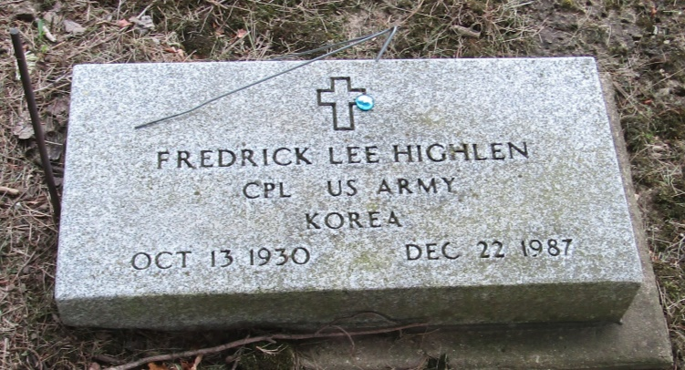

Fredrick Highlen
in the Texas, Death Index, 1903-2000
Name: Fredrick Highlen
Death Date: 22 Dec 1987
Death County: Nueces
Gender: Male

*****
U.S., Social Security Applications and Claims Index, 1936-2007
Name: Fred Lee Highlen
[Fredrick L Highlen ]
Gender: Male
Race: White
Birth Date: 13 Oct 1930
Birth Place: Liberty Center, Indiana
Death Date: 22 Dec 1987
Father: Lee R Highlen
Mother: Mabel E Thrailkill
SSN: xxx
Death Certificate Number: 119785
Notes: May 1948: Name listed as FRED LEE HIGHLEN; 22 May 1998: Name listed as FREDRICK L HIGHLEN

