Douglas Allen Helms
August 19, 1950 – November 4, 1975

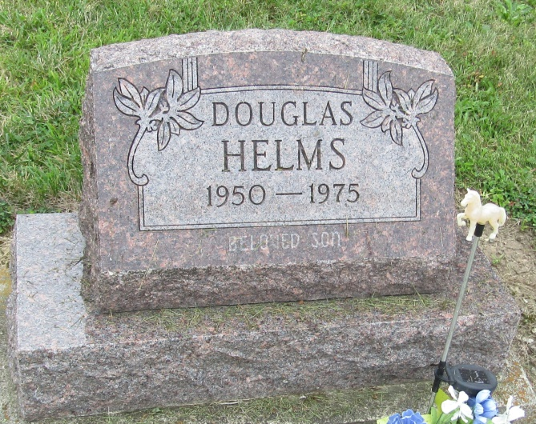

DOUGLAS HELMS, 25, DIES OF WOUND
Douglas A. Helms, 25, of Bluffton, Route 2 was found dead this morning of a self-inflicted gunshot wound to the head at his residence on County Rd. 550S, one-fourth mile east of Ind. 1. Time of death was placed between 8:30 and 10:30 a.m. with a 12-guage shotgun being found next to the body. No one else was at the residence at the time of the incident. The body was found in the upstairs bedroom.
The victim, who resided one-half mile north of Reiffsburg, had been in a despondent state in recent weeks, according to his mother, Mrs. Hilda Helms, who found the body. His father, Harry, was absent, driving a grain truck owned by Douglas. The victim also worked part time at Hulcher Emergency Railroad Service. County and State Police and Coroner Howard Rich investigated the matter.
Surviving, in addition to the parents, are two brothers, Roger of rural Liberty Center, and Kenneth, at home, and his maternal grandmother, Mrs. Ethel Harness of Warren.
The body was taken to Thoma-Rich Funeral Home.
Bluffton News-Banner, Wells County, Indiana
Wednesday, November 5, 1975
*****

DOUGLAS HELMS RITES THURSDAY
Funeral services for Douglas Allen Helms, 25, who died Tuesday morning at his home one-half mile north of Reiffsburg, will be at 1: 30 p.m. Thursday at Thoma-Rich Funeral Home; Rev. Edward Johnson officiating. Burial will be in Mossburg Cemetery.
A native of Indianapolis, Helms had owned a semi-trailer truck for produce and grain hauling. He was a 1958 graduate of Norwell High School.
Born Aug. 19, 1950, he was a son of Harry A. and Hilda Harness Helms, both of whom reside on Bluffton Route 2. Two brothers, Roger near Liberty Center, and Kenneth, at home, also survive.
In addition to his hauling business, Helms had been employed part time with Hulcher Emergency Railroad Service of Bluffton. His father assisted him in the trucking business.

Bluffton News-Banner, Wells County, Indiana
Wednesday, November 5, 1975
Page 3, Column 8

