William S. Heckman
November 30, 1848 – October 29, 1894

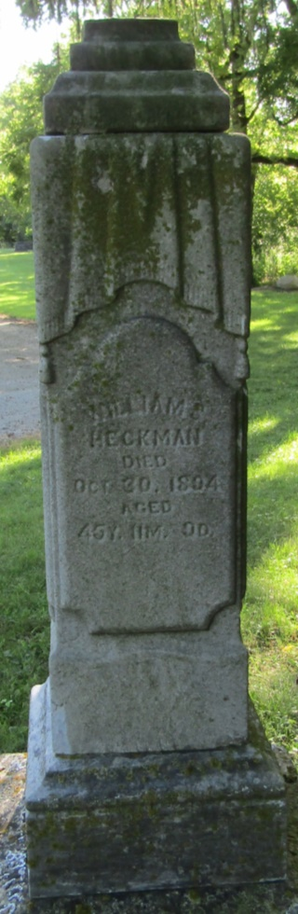

William Hickman [sic], of Liberty Township, died yesterday. His funeral will occur tomorrow under the direction of the Odd Fellows.

Bluffton Banner, Wells County, Indiana (weekly newspaper)
Wednesday, October 31, 1894
*****

Indiana, WPA Death Index, 1882-1920
Name: William S. Heckman
Date: 29 Oct 1894
Location: Wells County
Age: 46 Yr
Gender: Male
Race: White
Source location: County Health Office, Bluffton
Source Notes: The source of this record is the book H-14 on page 86 within the series produced by the Indiana Works Progress Administration.

