Mary B. Harvey
January 20, 1904 – June 25, 1975

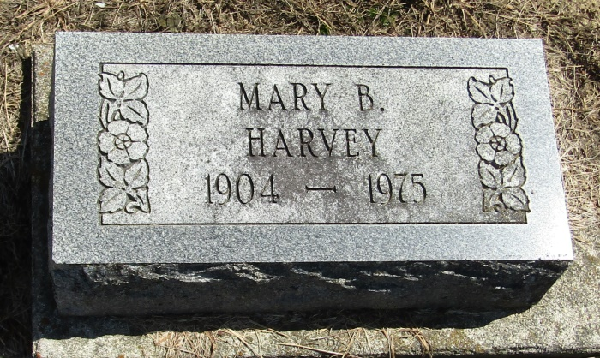

Mary B Harvey
in the Indiana, Death Certificates, 1899-2011
Name: Mary B Harvey
Gender: Female
Race: White
Age: 71
Marital status: Divorced
Birth Date: 20 Jan 1904
Birth Place: Indiana
Death Date: 25 Jun 1975
Death Place: Bluffton, Wells, Indiana, USA
Father: James C Harvey
Mother: Lillian Adkinson
Informant: John E. Harvey; Mendon, Michigan
Burial: June 27, 1975; Mossburg Cemetery; Liberty Center, Indiana

