Rachel Rebecca (Brinneman) Gregg
September 27, 1869 – April 6, 1940

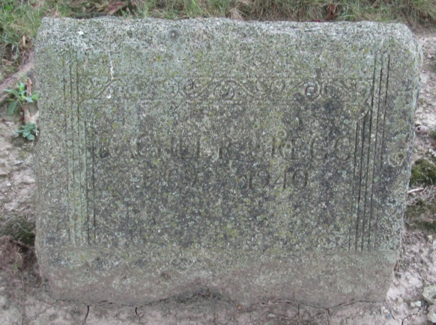

Rachel Rebeca Gregg
in the Indiana, Death Certificates, 1899-2011
Name: Rachel Rebeca Gregg
[Rachel Rebeca Brinneman]
Gender: Female
Race: White
Age: 70
Marital status: Married
Birth Date: 27 Sep 1869
Birth Place: Indiana
Death Date: 6 Apr 1940
Death Place: Liberty Center, Wells, Indiana, USA
Father: Jefferson Branneman
Mother: Susan Glass
Spouse: Joseph Gregg; age 68 years
Informant: Mrs. Hazel Hamilton; Liberty Center, Indiana
Burial: April 8, 1940; Mossburg Cemetery

