Orval J. Gerwig
December 11, 1900 – April 11, 1990

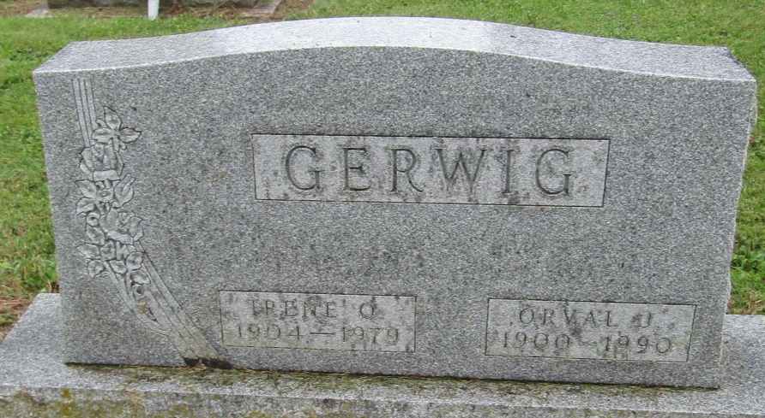

Orval J Gerwig
in the Indiana, Death Certificates, 1899-2011
Name: Orval J Gerwig
Gender: Male
Race: White
Age: 89
Marital status: Widowed
Birth Date: 11 Dec 1900
Birth Place: Wells County, IN
Death Date: 11 Apr 1990
Death Place: Warren, Huntington, Indiana, USA
Father: Henry F Gerwig
Mother: Cora Jackson
Informant: Roger Gerwig; son; Bluffton, Indiana
Burial: April 14, 1990; Mossburg Cemetery; Liberty Center, Indiana

