Kenneth L. Gerwig
February 10, 1924 – March 28, 2000

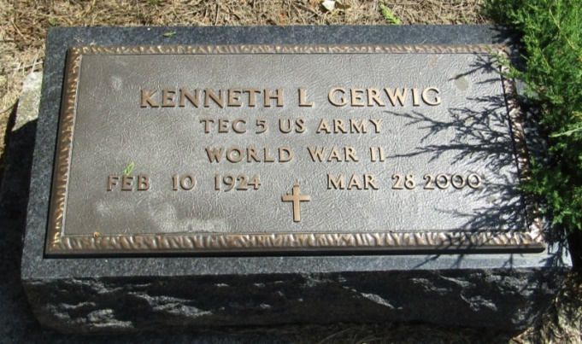

Kenneth L. Gerwig, 76, of Bluffton, a member of VFW Post 2809, died Tuesday, March 28, 2000, at Wells Community Hospital. The Liberty Center native was retired from GTE in Fort Wayne and was a World War II Army Air Corps veteran.
Surviving are a daughter, Diana L. Pickering of Sacramento, Calif.; a son, Gary L. of Sheridan, Ore.; a brother, Paul E. of Poneto; five grandchildren; and three great-grandchildren.

News-Sentinel, Allen County, Indiana
March 30, 2000

*****
Indiana, Death Certificates, 1899-2011
Name: Kenneth L. Gerwig
Gender: Male
Race: White
Age: 76
Marital status: Divorced
Birth Date: 10 Feb 1924
Birth Place: Liberty Center, in.
Death Date: 28 Mar 2000
Death Place: Bluffton, Wells, Indiana, USA
Father: Harry Gerwig
Mother: Gladys Wagner
Informant: Paul Gerwig; brother; Liberty Center, Indiana
Burial: April 1, 2000; Mossburg Cemetery; Liberty Center, Indiana

