Helen I. (Grove) Gerwig
September 16, 1917 – September 20, 1980

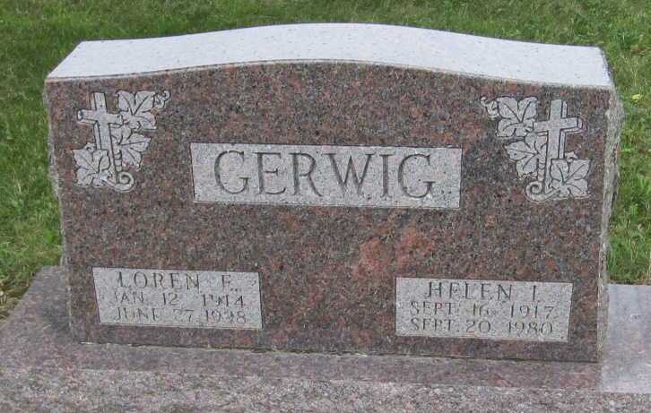

Helen I. Gerwig
in the Indiana, Death Certificates, 1899-2011
Name: Helen I. Gerwig
[Helen I. Grove]
Gender: Female
Race: White
Age: 63
Marital status: Married
Birth Date: 16 Sep 1917
Birth Place: Indiana
Death Date: 20 Sep 1980
Death Place: Mishawaka, St Joseph, Indiana, USA
Father: Charles Grove
Mother: Ada Bennett
Spouse: Loren Gerwig
Informant: Loren Gerwig; North Liberty, Indiana
Burial: September 24, 1980; Mossburg Cemetery; Bluffton, Indiana

