Samuel Gaskill
December 18, 1813 – December 1, 1893

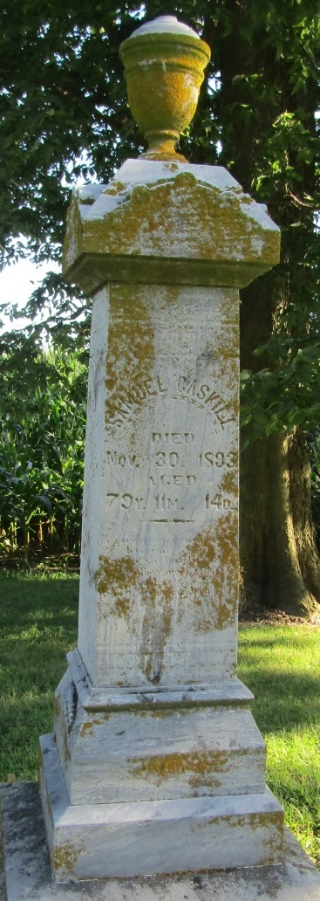

Last Friday morning occurred the death of Samuel Gaskill, an old and respected citizen of Liberty Township. He lacked but a few days of being eighty years of age. He was born in Burlington County, New Jersey and came to Wells County in the '40's and settled in Liberty township on the same farm on which he lived until the time of his death. He raised a large family there being five sons and eight daughters all grown to adult years and married. His wife was a sister of Daniel Glass living west of the city.
Mr. Gaskill was an excellent man and valued citizen, always maintaining the respect and esteem of his large circle of friends and neighbors.
His funeral occurred last Saturday.

Bluffton Banner, Wells County, Indiana (weekly newspaper)
Wednesday, December 6, 1893

*****
Biography
Samuel Gaskill, a resident of Liberty Township, settled in Wells County in November, 1853. He was born in New Jersey, December 18, 1813; served as Road Master and School Director. His parents, Benjamin and Mary (Brown) Gaskill, died in Ohio. He was married in Deerfield Township, Ohio, November 11, 1848, to Catherine Glass.
Their children are: Mary A., born April 8, 1850; Christina, January 8, 1852; Barbara A., October 12, 1853; Mathias J., March 11, 1856; Jonathan and John, May 8, 1858; Matilda, October 6, 1861; Edwin and Peter, January 15, 1863; Arena and Alvena, April 9, 1865; Margaret, June 8, 1867; Sarah, June 1, 1870.
Catherine Gaskill’s parents, Mathias and Polly (Kissner) Glass, died in Ohio. Two brothers of Samuel Gaskill served in the war of 1861. They were Jacob and Elijah. Jacob died of small-pox while in Tennessee. Business, farming. Address, Bluffton, Indiana.
Historical Hand Atlas, History of Wells County, Indiana, H. H. Hardesty, Toledo, 1881; Page 215

