Mary A. (Wooster) Gaskill
May 23, 1864 – March 29, 1936

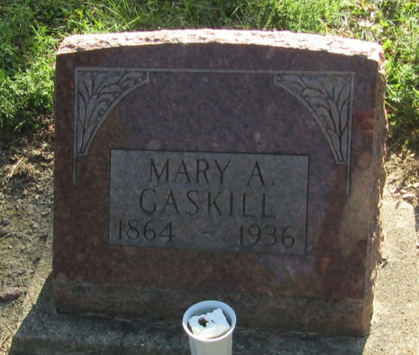

Mary A Gaskill
in the Indiana, Death Certificates, 1899-2011
Name: Mary A Gaskill
[Mary A Wooster]
Gender: Female
Race: White
Age: 71
Marital status: Widowed
Birth Date: 23 May 1864
Birth Place: Ind
Death Date: 29 Mar 1936
Death Place: Liberty Center, Wells, Indiana, USA
Father: Wm F Wooster
Mother: Thrailkill
Spouse: John Gaskill
Informant: Mrs. M. S. Stroud; Liberty Center, Indiana
Burial: March 31, 1936; Mossburg Cemetery

