Johnathon Gaskill
May 8, 1852 – February 15, 1942

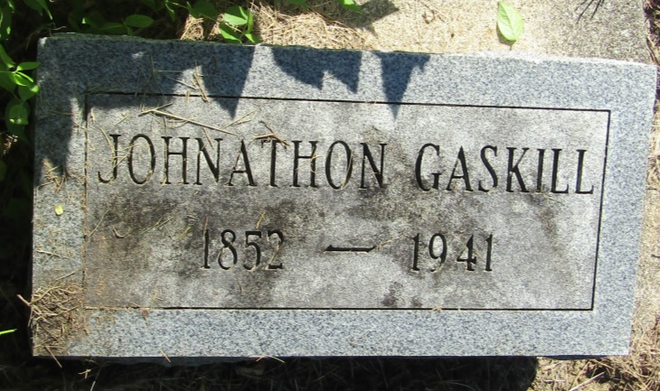

Johnathon Gaskill
in the Indiana, Death Certificates, 1899-2011
Name: Johnathon Gaskill
Gender: Male
Race: White
Age: 89
Marital status: Widowed
Birth Date: 8 May 1852
Birth Place: Wills, Co, Ind
Death Date: 15 Feb 1942
Death Place: Rural, Jay, Indiana, USA
Father: Samuel Gaskill
Mother: Catherine Gaskill
Spouse: Malinda Gaskill

