Irene Collier (Jackson) Garrison
February 27, 1896 – February 12, 1993

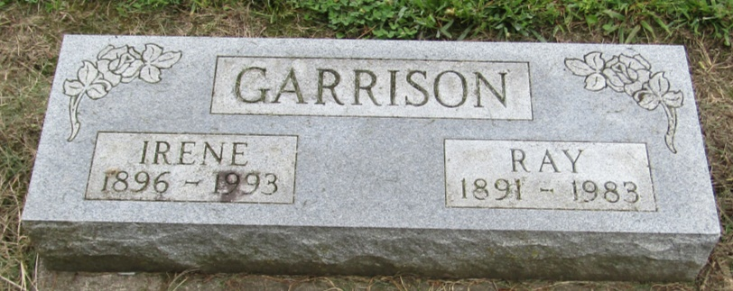

Irene Garrison
in the Indiana, Death Certificates, 1899-2011
Name: Irene Garrison
[Irene Collier]
Gender: Female
Race: White
Age: 96
Marital status: Widowed
Birth Date: 27 Feb 1896
Birth Place: Ingham Co, MI
Death Date: 12 Feb 1993
Death Place: Berne, Adams, Indiana , USA
Father: Jay Collier
Mother: Bertha
Informant: Ruth L. Evans; daughter; Bluffton, Indiana
Burial: February 14, 1993; Mossburg Cemetery; Liberty Center, Indiana

