Goldie M. (Badger) Fry-Tarr
July 16, 1881 – February 10, 1936

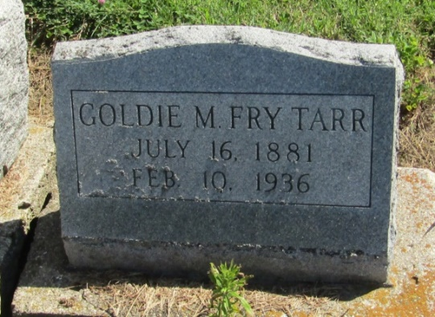

Mrs. Byron A. Tarr Answers Summons
Liberty Township Woman Dies after Extended Illness
Mrs. Byron A. Tarr, 54, died at 3 o'clock Monday afternoon at her home in Liberty Township, after an extended illness from complications. Born in Wabash on July 16, 1881, Mrs. Goldie M. Tarr was the daughter of Mr. and Mrs. Samuel Badger. Her marriage took place on Feb. 8, 1920, in Bluffton.
Surviving are the husband; a son by a former marriage, Paul F. Fry, of Marion; four step-children, Victor A. Tarr, of Huntington; Albert N. Tarr, of Bluffton; Edna A. Tarr, of Fort Wayne, and Robert E. Tarr, at home. Brothers and sisters surviving are Mrs. Iona Myers and Harry Badger, both of Huntington; Arthur Badger, of Wabash; and Edgar Badger, whose address is unknown.
Funeral services will be held at 2 o'clock Thursday afternoon at the Liberty Center M. P. church, of which Mrs. Tarr was a member, in charge of Rev. A. L. Steinfelt. Burial will be in the Mossburg Cemetery.

Bluffton Evening News, Wells County, Indiana
Tuesday, February 11, 1936

*****
Indiana, Death Certificates, 1899-2011
Name: Goldie M Tarr
[Goldie M Badger]
Gender: Female
Race: White
Age: 54
Marital status: Married
Birth Date: 16 Jul 1881
Birth Place: Indiana
Death Date: 10 Feb 1936
Death Place: Liberty, Wells, Indiana, USA
Father: Samuel Badger
Mother: Sarah Badger
Spouse: Byron Tarr
Informant: Byron Tarr; Liberty Center, Indiana
Burial: February 13, 1936; Mossburg Cemetery

