Juanita (McKinley) Fritz-Arnold
May 27, 1927 – November 16, 1976

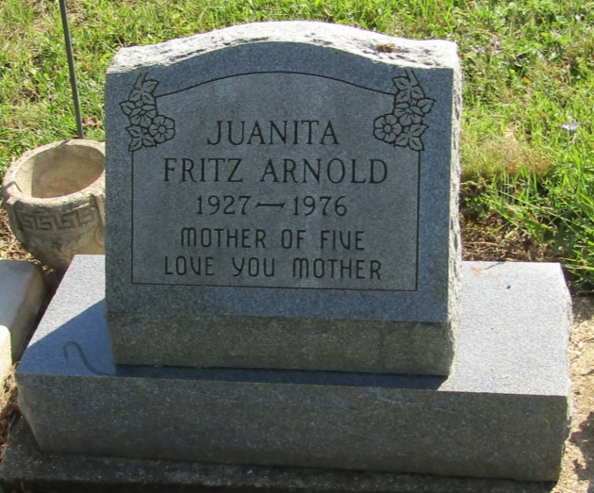

Juanita Arnold
in the Indiana, Death Certificates, 1899-2011
Name: Juanita Arnold
[Juanita McKindley]
Gender: Female
Race: White
Age: 49
Marital status: Married
Birth Date: 27 May 1927
Birth Place: Virginia
Death Date: 16 Nov 1976
Death Place: Fort Wayne, Allen, Indiana, USA
Father: William McKindley
Mother: Tishia Hall
Spouse: James Arnold
Informant: James Arnold; husband; Liberty Centery, Indiana
Burial: November 19, 1976; Mossburg Cemetery; Liberty Center, Indiana

