Harry K. Fristoe
June 10, 1872 – February 1, 1923

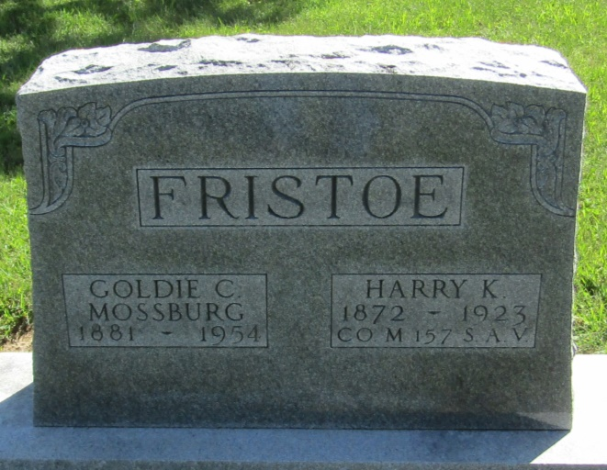

Harry Fenston
in the Indiana, Death Certificates, 1899-2011
Name: Harry Fristoe
Gender: Male
Race: White
Age: 50
Marital status: Married
Birth Date: 10 Jun 1872
Birth Place: Crawford Co., Ohio
Death Date: 1 Feb 1923
Death Place: Bluffton, Wells, Indiana, USA
Father: George O. Fristoe
Mother: Olive E. Trinsori
Spouse: Goldie Mossburg
Informant: Mrs. Harry Fristoe; Bluffton, Indiana
Burial: February 4, 1923; Mossburg Cemetery

