Chauncey E. Frantz
January 2, 1908 – November 18, 1971

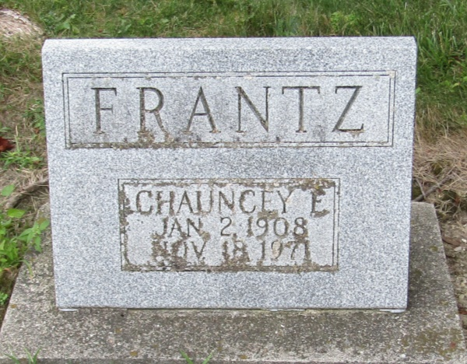

Chauncey E. Frantz, 63, who had resided in Phoenix, Arizona the past 1-1/2 years, died Thursday at Baptist General Hospital in Phoenix.
Born January 2, 1908 in Wells County, he was a son of James and Harriett Boltin Frantz. He was a member of the Presbyterian Church.
Surviving are a sister, Mrs. Mary Jane Gingerick of Markle, and two brothers, Paul Frantz of Liberty Center and Sherman Frantz of Indianapolis.
Services will be Monday at the Thoma Funeral Home with Rev. Myron Hinton officiating; burial in the Mossburg Cemetery.

Wells County, Indiana Obituaries
1969 – 1975

*****
Newspapers.com Obituary Index, 1800s-current
Name: Chauncey E. Frantz
Gender: Male
Death Age: 63
Birth Date: abt 1908
Residence Place: Hammond
Death Date: Abt 1971
Death Place: Phoenix, Ariz.
Burial Place: Bluffton
Obituary Date: 21 Nov 1971
Obituary Place: Munster, Indiana, United States of America
*****
U.S., Social Security Death Index, 1935-2014
Name: Chauncey Frantz
Social Security Number: xxxx
Birth Date: 2 Jan 1908
Issue Year: Before 1951
Issue State: Indiana
Last Residence: 85021, Phoenix, Maricopa, Arizona, USA
Death Date: Nov 1971

