Solomon First
May 16, 1834 – August 22, 1909

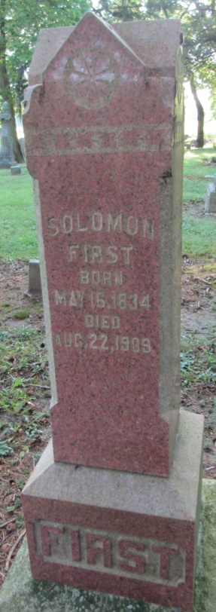
Photo by Bruce Sonner

Death of Pioneer in Liberty Township
Solomon First Passed Away Monday from Infirmities of Advances Years
Solomon First, aged about 70, passed away Monday morning at his home east of Liberty Center, death being due to the infirmities of his advanced age. He had long suffered from rheumatism. The deceased was one of the pioneers of that section and had lived in Liberty Township for many years, and was one of the best known citizens of that vicinity.
He is survived by two daughters and two sons, namely Jacob and Miss Sarah First, who lived with their father, Mrs. Hiram Mossburg, and Robert First, who is in the Easthaven Hospital at Richmond.
The funeral services were held this forenoon at the West Liberty Church with burial in the Mossburg Cemetery.

Bluffton Evening News, Wells County, Indiana
Tuesday, August 24, 1909

*****
Indiana, Death Certificates, 1899-2011
Name: Soloman First
Gender: Male
Race: White
Age: 75
Marital status: Widowed
Birth Date: 16 May 1834
Birth Place: Ohio
Death Date: 22 Aug 1909
Death Place: Liberty, Wells, Indiana, USA
Father: Jacob First
Mother: Hanna Stonebrook
Informant: Jacob First; Liberty Center, Indiana
Burial: August 24, 1909; Mossburg Cemetery

