Mary Elizabeth (Fritz) Fields
September 17, 1923 – April 11, 1991

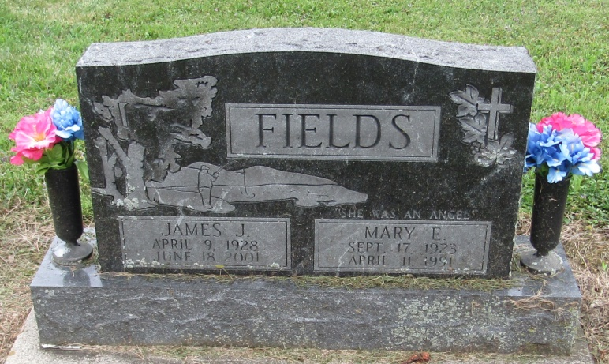

Mary Elizabeth Fields
in the Indiana, Death Certificates, 1899-2011
Name: Mary Elizabeth Fields
[Mary Elizabeth Fritz]
Gender: Female
Race: White
Age: 67
Marital status: Married
Birth Date: 17 Sep 1923
Birth Place: Inman, Virginia
Death Date: 11 Apr 1991
Death Place: Bluffton, Wells, Indiana, USA
Father: William Fritz
Mother: Tisha Hall
Spouse: James J Fields
Informant: James J. Fields; spouse; Bluffton, Indiana
Burial: April 13, 1991; Mossburg Cemetery; Liberty Center, Indiana

