Mary Alice (Crisamore) Fair
January 14, 1942 – August 22, 2017

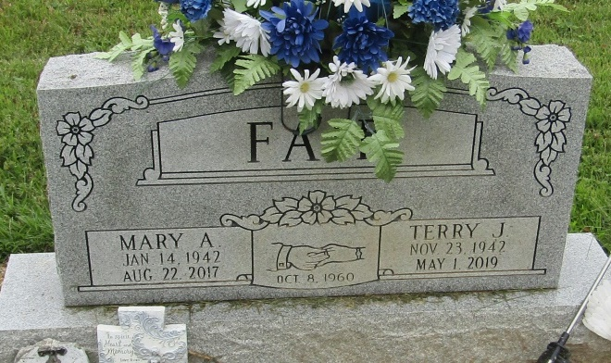

Mary Alice Fair, 75

Hartford City – Mary Alice Fair, 75, of Hartford City, IN, passed away at 8:24 a.m. on Tuesday, August 22, 2017, at IU Health Blackford Hospital in Hartford City, IN. She was born on Wednesday, January 14, 1942, in Montpelier, IN. She married Terry James Fair on Saturday, October 08, 1960 in Warren, IN.
Mary attended Jackson Center schools in Wells County, IN. She had lived in Nashville, TN. for 21 years. She enjoyed cooking, and especially spending time with her family.
Loving Survivors Include: Husband - Terry James Fair, Hartford City, IN, Daughter - Debra J. Henderson, Montpelier, IN, Son - Robert F. Fair, Roll, IN, Sister - Arlet Trosper, Montpelier, IN, Sister - Martha Hartley, Montpelier, IN, Brother - James A. Crisamore, Hartford City, IN, Grandson- Michael Henderson, Hartford City, IN, and 5 Great Grandchildren. She was preceded in death by her Father - Lester Fay Crisamore, Mother - Freda E. (Barrett) Crisamore, and Granddaughter - Jennifer Henderson.
Family and friends may gather to share and remember at Walker & Glancy Funeral Home 109 W Windsor St Montpelier on Saturday, August 26, 2017 from 4:00 p.m. to 8:00 p.m. A service to celebrate Mary's life will be at Walker & Glancy Funeral Home at 2:00 p.m. on Sunday, August 27, 2017, with the Rev. Dewey Zent officiating. Interment will follow in the Mossburg Cemetery in Liberty Center.
Arrangements are being handled by Walker & Glancy Funeral Home in Montpelier.
The Star Press, Huntington County, Indiana
August 24, 2017

