Dessie M. (Sliger) Eubank-Vickrey
August 23, 1895 – June 22, 1952

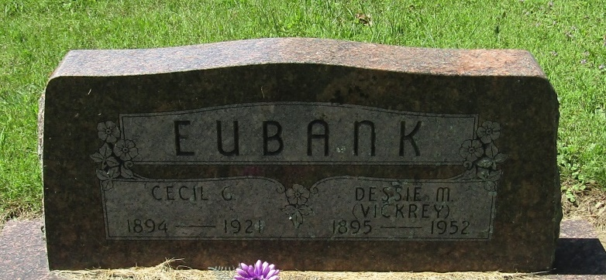

Dessie M Vickrey
in the Indiana, Death Certificates, 1899-2011
Name: Dessie M Vickrey
[Dessie M Saager]
Gender: Female
Race: White
Age: 56
Marital status: Married
Birth Date: 23 Aug 1895
Birth Place: Grand View Indiana
Death Date: 22 Jun 1952
Death Place: Bluffton, Wells, Indiana, USA
Father: John M Sliger
Mother: Lillie Conn
Informant: Mrs. Wm. B. Inskeep; Liberty Center, Indiana
Burial: June 25, 1952; Mossburg Cemetery

