Anna Maria Ernst
May 20, 1865 – June 2, 1865

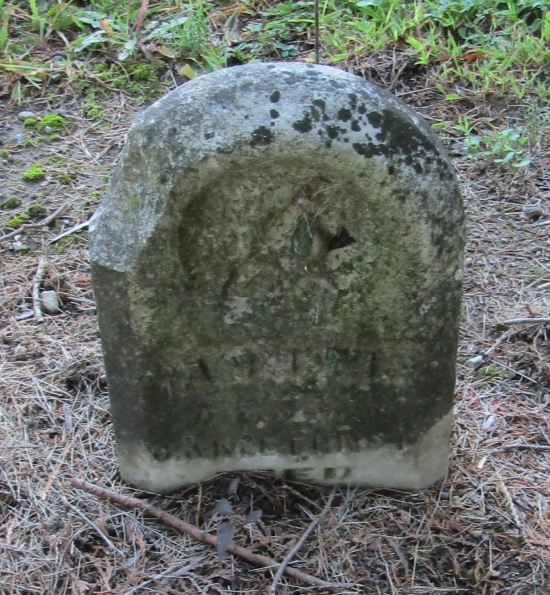

No further information found at this time

