Priscilla (Mathias) Eckhart
February 8, 1829 – September 8, 1894

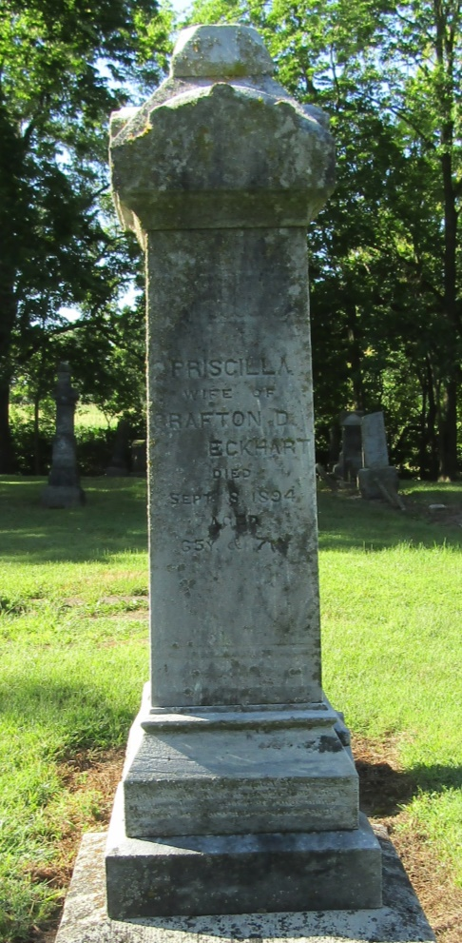

Mrs. G. D. Eckhart, of Liberty Center, who died of typhoid fever, was buried in the Mossburg cemetery last Sunday.

Bluffton Banner; Wells County, Indiana
A weekly newspaper
Wednesday, September 12, 1894

