Infant Eckhart
August 31, 1918 – August 31, 1918

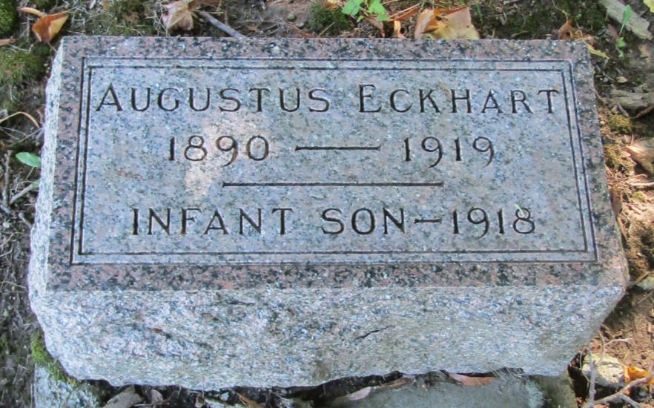

Infant Eckhart
in the Indiana, Death Certificates, 1899-2011
Name: Infant Eckhart
Gender: Male
Race: White
Age: 0
Birth Date: 31 Aug 1918
Birth Place: Wells Co, Ind
Death Date: 31 Aug 1918
Death Place: Harison, Wells, Indiana, USA
Father: Augustus Eckhart
Mother: Magie Abshire
Burial: September 1, 1918; Mossburg Cemetery

