Adeline (Griffin) Denning
1871 – February 4, 1898

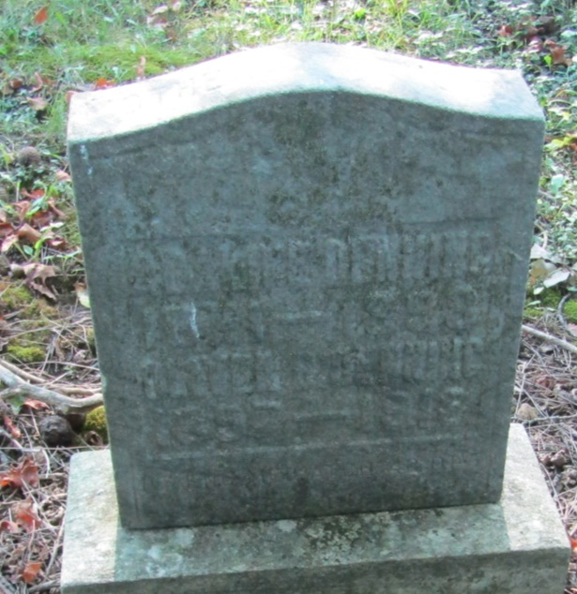

No further information found at this time

