Paul Mason Day
February 25, 1908 – July 25, 1909

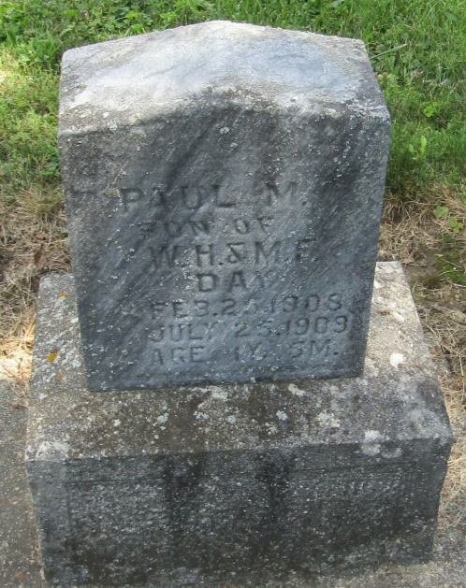

Baby Dead at Bly
Paul Mason Day, aged one year and five months, little son of Mr. and Mrs. William H. Day, living near Bly, died Sunday morning, after a two weeks illness, which developed into cholera infantum.
The funeral was held this forenoon, with burial at the Mossburg cemetery.
The deceased child is survived by the parents and one older boy, Frank, aged six years.
Bluffton News Banner, Wells County, Indiana
Monday, July 26, 1909

*****
Indiana, Death Certificates, 1899-2011
Name: Paul Mason Day
Gender: Male
Race: White
Age: 1
Birth Date: 25 Feb 1908
Birth Place: Wells Co Ind
Death Date: 25 Jul 1909
Death Place: Liberty, Wells, Indiana, USA
Father: Wm Henry Day
Mother: Minnie Floretta Buckner
Informant: W. H. Day; Liberty Center, Indiana
Burial: July 28, 1909; Mossburg Cemetery

