Minnie Floretta (Buckner) Day
March 17, 1879 – November 27, 1978

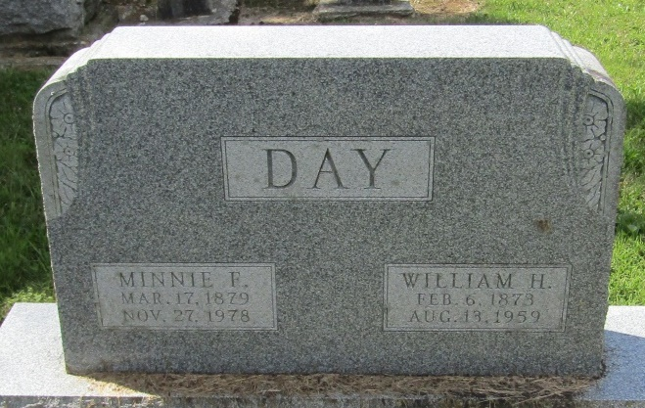

Mrs. W. H. Day Dies at Age 99; Rites Wednesday
A former resident of 209 West Wabash St., Mrs. William H. (Minnie Floretta) Day, 99, who had resided the past seven years at Meadowvale Care Center, died at 12:30 a.m. today at Wells Community Hospital, where she had been a patient since Nov. 19.
Family members gathered at Meadowvale Care Center March 17 of this year to help Mrs. Day observe her 99th birthday.
Her husband, the late William Henry Day, was a farmer and lay minister many years. He served as pastor of the Pleasant Mills Baptist Church for 30 years and at the Poneto Baptist Church 15 years.
Mrs. Day was an avid flower grower and held a special love for dahlias, over which she won many prizes at fairs and which she also provided for the church. A member of the Liberty Center Baptist Church, Mrs. Day was born March 17, 1879 in Liberty Twp. to John T. and Lurena Prible Buckner. Her marriage to Mr. Day, who died in 1959, took place June 10, 1900 in Liberty Center.
Surviving are two sons, Frank E. Day, of Sebring, Fla., and Charles E. Day of Huntington Route 4, four grandchildren, 5 great-grandchildren and one great-great-grandchild.
Calling will be after 1 p.m. Tuesday at the Thoma-Rich Funeral Home, where services at 10:30 a.m. Wednesday will be in charge of Rev. A. N. Corpening. Burial will be in the Mossburg Cemetery.
Bluffton News Banner, Wells County, Indiana
Monday, November 27, 1978

*****
Indiana, Death Certificates, 1899-2011
Name: Minnie Floretta Day
[Minnie Floretta Bucker]
Gender: Female
Race: White
Age: 99
Marital status: Widowed
Birth Date: 17 Mar 1879
Birth Place: Indiana
Death Date: 27 Nov 1978
Death Place: Bluffton, Wells, Indiana , USA
Father: John T Buckner
Mother: Lurena Brible
Informant: Charles E. Day; Huntington, Indiana
Burial: November 29, 1978; Mossburg Cemetery; Liberty Center, Indiana

