Harley Russell Dalrymple
August 2, 1892 – February 18, 1901

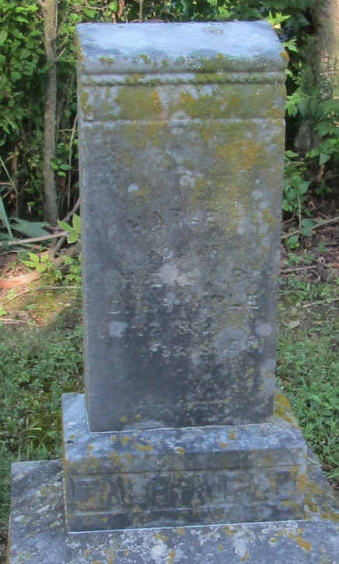

Harley Russell Dalrymple
in the Indiana, Death Certificates, 1899-2011
Name: Harley Russell Dalrymple
Gender: Male
Race: White
Age: 8 years, 6 months, 16 days
Birth Date: abt 1893
Birth Place: Huntington Co
Death Date: 18 Feb 1901
Death Place: Liberty, Wells, Indiana, USA
Father: Henry Eli Dalrymple
Mother: Anna Luckey
Informant: John Mossburg; Liberty Center, Indiana
Burial: February 19, 1901; Mossburg Cemetery

