Anna Belle (Luckey) Dalrymple
October 1, 1871 – June 16, 1904

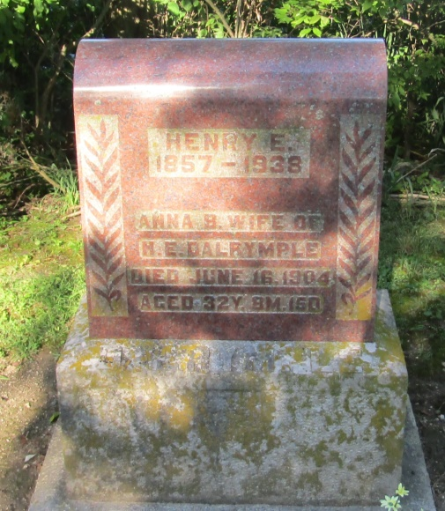

Anna Bell Dalrymple, wife of Henry C. Dalrymple, was born Oct. 1, 1871, and departed this life June 16, 1904, aged 32 years, 8 months, and 15 days. Her marriage to Henry E. Dalrymple occurred Dec. 3, 1887. To them were born two boys, Jesse Edward and Harlie Russell. Harlie died February 18, 1901; also father and three sisters preceded her to the better land.
In the year 1890, she united with the Beohmer M. P. Church and remained a faithful member until death. But not being satisfied with her spiritual condition, she came forward to the altar of prayer in a meeting held by the writer, two years ago in Liberty Center and was happily converted to God and enjoyed much of His presence. Since that time during her long and tedious illness she manifested a sweet Christian spirit. On an evening not long before her death she called her pastor and wife with her family and other friends to pray and sing with her. And during this season of prayer, heaven seemed to be opened to her vision and she talked in loving tones to little Harlie and other departed ones. She expected all to meet her in heaven and to Harlie she said: "Never mind, darling, Mamma will soon be with you." She joined in the songs and was very happy. Only a little while was she compelled to suffer after this when God in mercy kissed away her life and took her to Himself.
Sister Dalrymple was a real bright, cheerful, good woman. A faithful wife, a loving mother, a kind neighbor and friend. Truly we can say a good woman is gone. In her death she leaves husband, son, mother, brother and two sisters with a host of relatives and friends to mourn her absence.
The funeral sermon was preached by the writer to a large audience in the M. P. church of Liberty Center, after which interment took place at Mossburg Cemetery.
--J. L. Barclay

**
Indiana, Death Certificates, 1899-2011
Name: Annie Bell Dalrymple
[Amie Bell Center]
Gender: Female
Race: White
Age: 32
Marital status: Married
Birth Date: 1 Oct 1871
Birth Place: Huntington Co Ind
Death Date: 16 Jun 1904
Death Place: Liberty, Wells, Indiana , USA
Father: Barney Luckey
Mother: Margeret McElhaney
Informant: Henry Dalrymple; Liberty Center, Indiana
Burial: June 18, 1904; Mossburg Cemetery

