Eliza Jane (Ernst) Croasdale-Merriman
December 12, 1858 – July 9, 1937

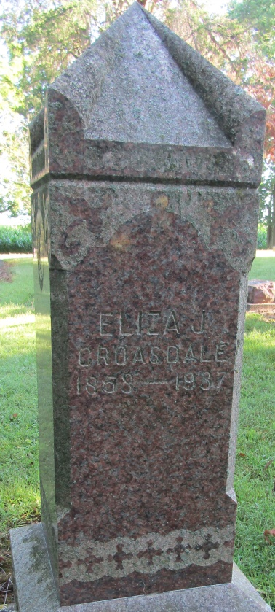

Eliza Jane Mauerman
in the Indiana, Death Certificates, 1899-2011
Name: Eliza Jane Merriman
[Eliza Jane Ernst]
Gender: Female
Race: White
Age: 78
Marital status: Widowed
Birth Date: 12 Dec 1858
Birth Place: Ohio
Death Date: 9 Jul 1937
Death Place: Liberty, Wells, Indiana , USA
Father: John Ernst
Mother: Mary Ellen Zergler
Spouse: 1st: Robert Croasdale, deceased; 2nd: John Merriman, deceased
Informant: Mrs. W. E. Thrailkill; Liberty Center, Indiana
Burial: July 11, 1937; Mossburg Cemetery

