Mary Luella (Gregg) Craig
March 22, 1912 – October 24, 1987

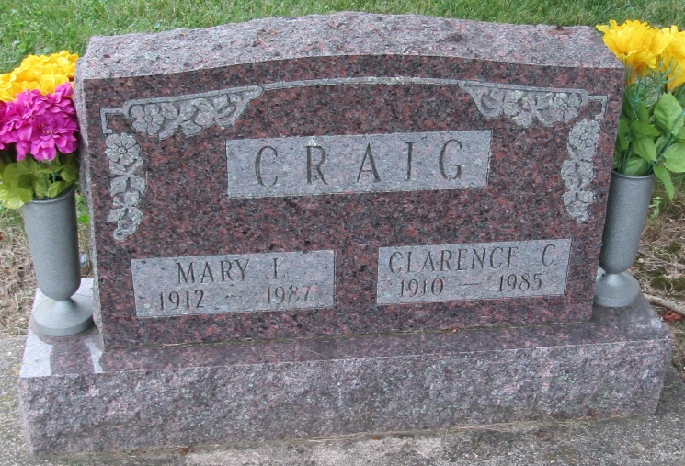

Mary Luella Craig
in the Indiana, Death Certificates, 1899-2011
Name: Mary Luella Craig
[Mary Luella Gregg]
Gender: Female
Race: Wh
Age: 75
Marital status: Widowed
Birth Date: 22 Mar 1912
Birth Place: Indiana
Death Date: 24 Oct 1987
Death Place: Bluffton, Wells, Indiana, USA
Father: Joseph D Gregg
Mother: Rachel Brinneman
Informant: Amie Mounsey; daughter; Bluffton, Indiana
Burial: October 27, 1987; Mossburg Cemetery; Bluffton, Indiana

