Clarence C. Craig
March 13, 1910 – September 5, 1985

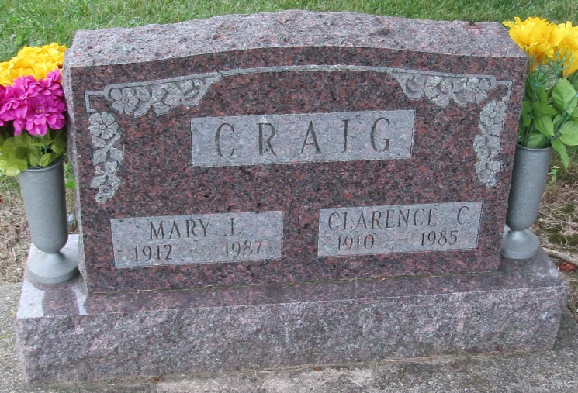

Clarence C Craig
in the Indiana, Death Certificates, 1899-2011
Name: Clarence C Craig
Gender: Female
Race: White
Age: 75
Marital status: Married
Birth Date: 13 Mar 1910
Birth Place: Indiana
Death Date: 5 Sep 1985
Death Place: Bluffton, Wells, Indiana , USA
Father: Clarence G Craig
Mother: Elizabeth Crawford
Spouse: Mary Gregg
Informant: Mary Craig; wife; Bluffton, Indiana
Burial: September 8, 1985; Mossburg Cemetery; Wells County, Indiana

