Esther Loretta (Moore) Cole
September 8, 1893 – August 10, 1974

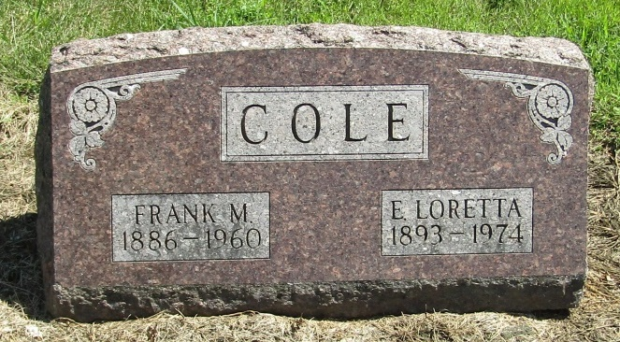

Mrs. Esther “Loretta” Cole, 80, of Liberty Center, widow of Frank M. Cole died Saturday at Wells Community Hospital. She was a life-long resident of Wells County.
Born September 8, 1893, a daughter of Aaron C. and Gertie Jones Moore. Her husband died in 1960. She was a member of the United Methodist Church at Liberty Center.
Surviving are one daughter, Mrs. Gertrude Frantz of Bluffton, one son, Marion C. Cole of Lincoln Park, Michigan, one sister, Mrs. Ralph (Delene) Kleinknight of Bluffton, Route 4, three grandchildren and three great grandchildren.
Services will be Tuesday at the United Methodist Church with Rev. Gerald Hewson officiating; burial in Mossburg Cemetery with Thoma-Rich Funeral Home in charge.

Wells County, Indiana Obituaries
August 10, 1974

**

Esther Loretta Cole
in the Indiana, Death Certificates, 1899-2011
Name: Esther Loretta Cole
[Esther Loretta Moore]
Gender: Female
Race: White
Age: 80
Marital status: Widowed
Birth Date: 8 Sep 1893
Birth Place: Indiana
Death Date: 10 Aug 1974
Death Place: Bluffton, Wells, Indiana, USA
Father: Aaron C Moore
Mother: Gertie Jones
Informant: Mrs. Gertrude Frantz; daughter
Burial: August 13, 1974; Mossburg Cemetery; Wells County

**

