Mary M. (Jones) Campbell
December 5, 1880 – May 1, 1936

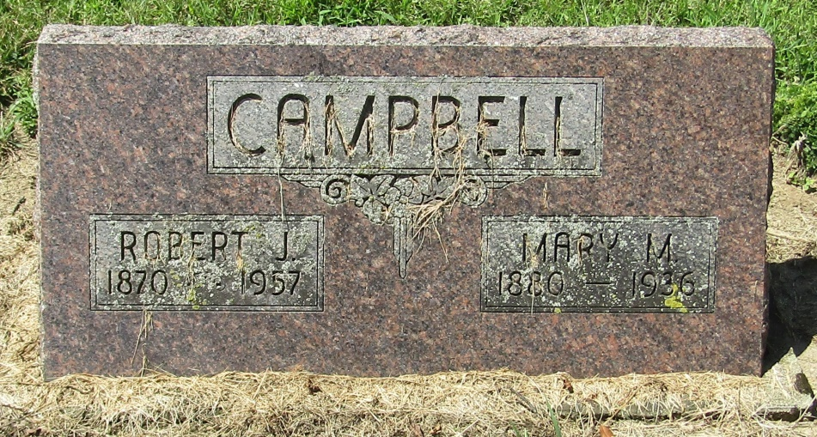

Mrs. Mary Campbell Dies This Morning
Death at Home near Liberty Center of Blood Clot, Following Illness
Mrs. Jacob Campbell, 55, died at 12:30 a.m. today at her home near Liberty Center of a blood clot which resulted from an operation she had undergone three weeks ago. She had been ill previous to the operation. Born Dec. 5, 1880, in Wells County, Mrs. Mary Campbell was the daughter of James M. and Catherine Shidler Jones.
Surviving are the mother, who lives in Vandalia, Mich.; the husband; the children, Mrs. Roy Brown, of Mt. Pleasant, Mich.; Mrs. Arlie Blake, of Gas City; Mrs. George Desper, of Muncie; Ocel Campbell of Poneto; Milton Campbell, of Gas City, and Donald, at home and the brothers and sisters, Mrs. A. C. Moore, of Liberty Center; Mrs. Daniel Holderman, of Michigan; Williard Jones, of Vandalia, Mich., and Boyd C. Jones, of Michigan.
Funeral services will be held at 10 a.m. Sunday at the Boehmer M. P. Church, of which she was a member. Burial will be in the Mossburg Cemetery.

Bluffton News Banner, Wells County, Indiana
Friday, May 1, 1936

