Virginia Olga Bumgarner
March 2, 1917 – March 11, 1920

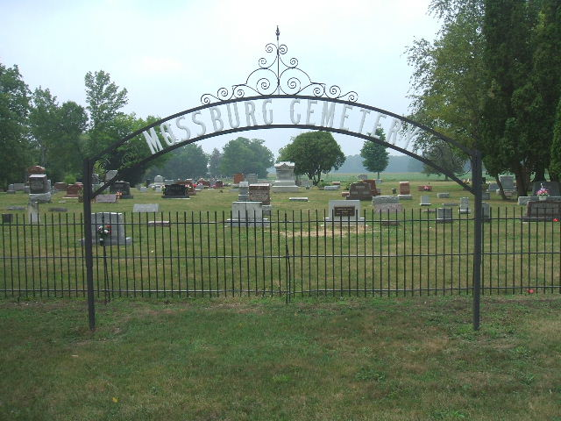
Photo by Tombstoner & Family

Virgina Olga Bumgarner
in the Indiana, Death Certificates, 1899-2011
Name: Virgina Olga Bumgarner
Gender: Female
Race: White
Age: 3 years, 9 days
Birth Date: 2 Mar 1917
Birth Place: Indiana
Death Date: 11 Mar 1920
Death Place: Indianapolis, Marion, Indiana, USA
Father: Ira Bumgarner
Mother: Idella Heller
Burial: March 14, 1920; Liberty Center, Indiana

