Marylou (Johnston) Bumgarner
July 28, 1933 – March 23, 2018

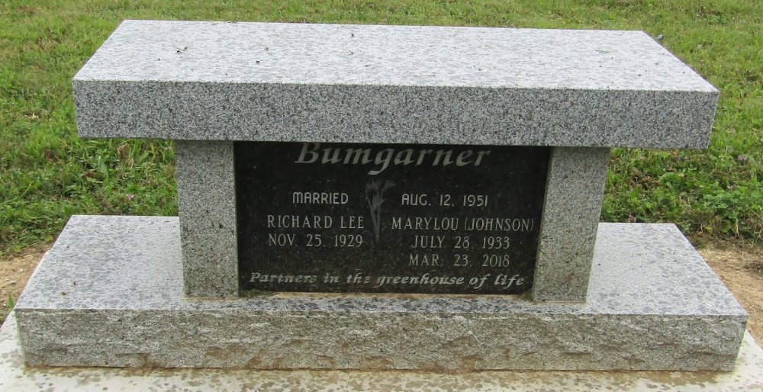

Marylou Bumgarner, 84, of Bluffton passed away on Friday evening, March 23, 2018, at her residence in Bluffton. She was born on July 28, 1933 in Bluffton, Indiana to Harry & Helen (Jacobs) Johnston.
She graduated from Bluffton High School in 1951 and operated Bumgarner Greenhouse in Bluffton from 1968 until 2017. She also was manager of Progress Craft Store and Yogurt Shop for 18 years, and worked at Murphy’s Dime Store in Bluffton for 3 years. Marylou was a member of the First Reformed Church, Bluffton, and was a member of the Bluffton Bowling Hall of Fame. Marylou married Richard L. Bumgarner on August 12, 1951 in Bluffton, IN, he survives.
Survivors include three sons; Steve (Jill) Bumgarner of Ft. Wayne, Michael (Sharlene) Bumgarner of Edwardsburg, MI and Keith (Karen) Bumgarner of Grant, MI. Marylou is survived by four grandchildren: Carri (Ron) Haller, Kelli Bumgarner, Jordan Bumgarner and Haley Bumgarner and 4 great-grandchildren: Kaylee Haller, Brayden Haller, Adelynn Haller and Eve Bumgarner. A brother; Ted (Marge) Johnson of Bluffton, and a sister; Sally Miller of Bluffton, IN. Marylou is preceded in death by a granddaughter; Kate Bumgarner.
Marylou enjoyed bowling, cooking for her family and traveling to Minnesota with her husband on fishing trips. She was a Cub Scout Den Mother for several years and along with her husband Richard, maintained the Bluffton downtown flower pots for many years.
Funeral services will be held at 11:00 A.M. on Thursday (March 29, 2018) at the Goodwin – Cale & Harnish Memorial Chapel in Bluffton with Pastor Heath Lisenby officiating. Calling Hours will be from 2:00 to 8:00 P.M. on Wednesday, and Thursday from 10:00 A.M. till service time. Burial will follow at Mossburg Cemetery, Wells County, IN. Memorials may be made to Friends Who Care Cancer Relief Foundation through the funeral home.
Funeral arrangements have been entrusted to the care of the Goodwin – Cale & Harnish Memorial Chapel in Bluffton

Goodwin Memorial Chapel, Wells County, Indiana
March 24, 2018

