Idella Elizabeth (Heller) Bumgarner
November 10, 1882 – October 13, 1955

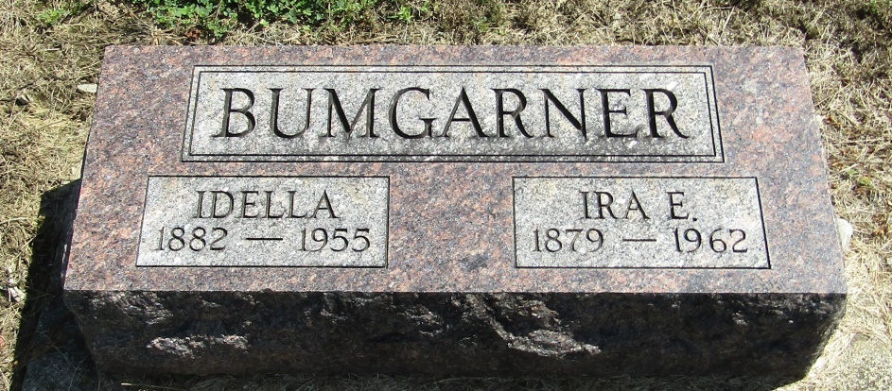
Photo by Tombstoner & Family

Idella Bumgarner
in the Indiana, Death Certificates, 1899-2011
Name: Idella Bumgarner
[Idella Heller]
Gender: Female
Race: White
Age: 72
Marital status: Married
Birth Date: 10 Nov 1882
Birth Place: Wells County, Indiana
Death Date: 13 Oct 1955
Death Place: Indianapolis, Marion, Indiana, USA
Father: Joseph Heller
Mother: Amanda Gentis
Informant: Ira E. Bumgarner; same address
Burial: October 17, 1955; Mossburg Cemetery; Wells County

