John Thomas Buckner
April 13, 1852 – April 20, 1933

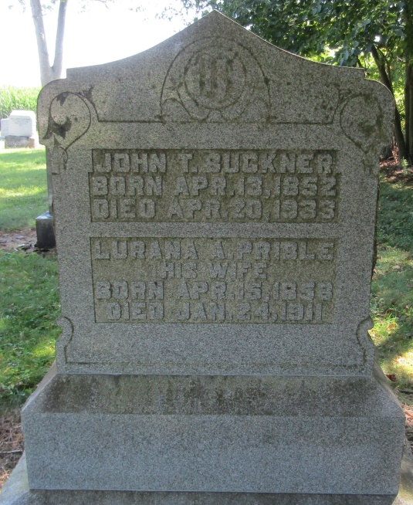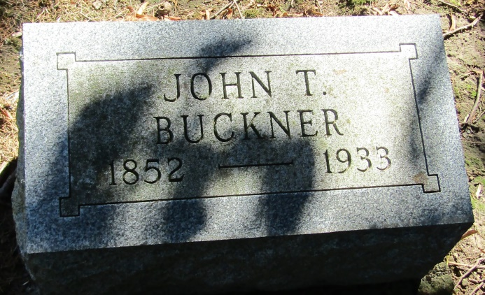

John S. Buckner
in the Indiana, Death Certificates, 1899-2011
Name: John T. Buckner
Gender: Male
Race: White
Age: 81
Marital status: Widowed
Birth Date: 13 Apr 1852
Birth Place: Kentucky
Death Date: 20 Apr 1933
Death Place: Bluffton, Wells, Indiana, USA
Father: Wm. N. Buckner
Mother: Amelia Yelton
Informant: Mrs. W. H. Day
Burial: April 23, 1933; Mossburg Cemetery

