Ivy May (Williams) Buckner
March 10, 1880 – January 17, 1961

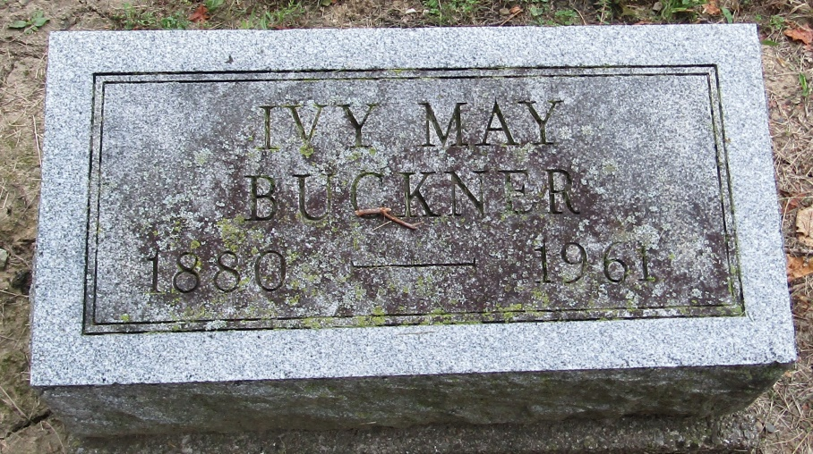

Ivy May Buckner
in the Indiana, Death Certificates, 1899-2011
Name: Ivy May Buckner
[Ivy May Williams]
Gender: Female
Race: White
Age: 80
Marital status: Married
Birth Date: 10 Mar 1880
Birth Place: Indiana
Death Date: 17 Jan 1961
Death Place: Ft Wayne, Allen, Indiana , USA
Father: James B Williams
Informant: Walter Buckner; husband; Huntington, Indiana
Burial: January 20, 1961; Mossburg Cemetery; Wells County, Indiana

