Charles Nicholas Buckner
January 1, 1854 – November 25, 1932

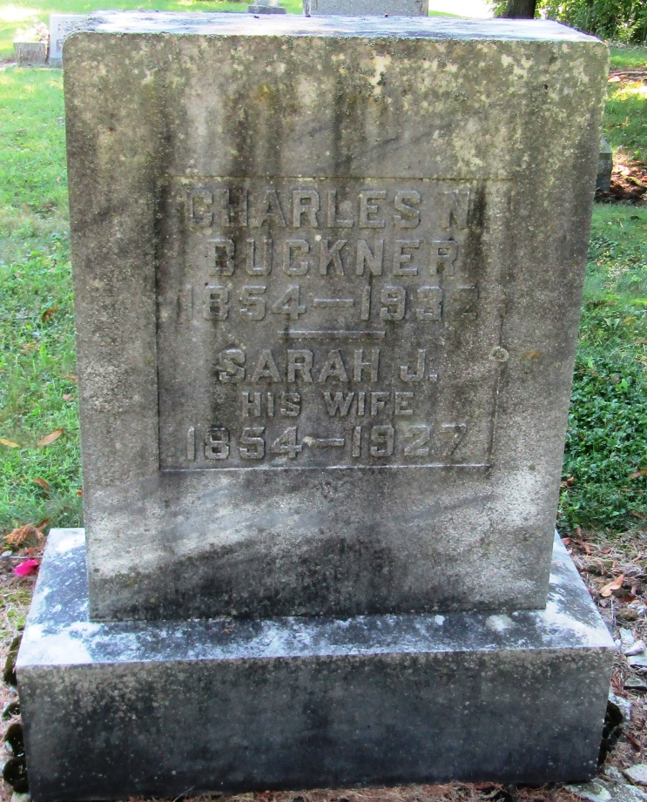

Chales N. Buckner
in the Indiana, Death Certificates, 1899-2011
Name: Charles N. Buckner
Gender: Male
Race: White
Age: 78
Marital status: Widow
Birth Date: 1 Jan 1854
Birth Place: Pendleton Co. Kentucky
Death Date: 25 Nov 1932
Death Place: Bluffton, Wells, Indiana, USA
Father: W.N. Buckner
Mother: Amelia M Yelton
Informant: Mrs. Herman Pace; Liberty Center, Indiana
Burial: November 27, 1932; Mossburg Cemetery

