John C. Brown
1837 – November 9, 1874

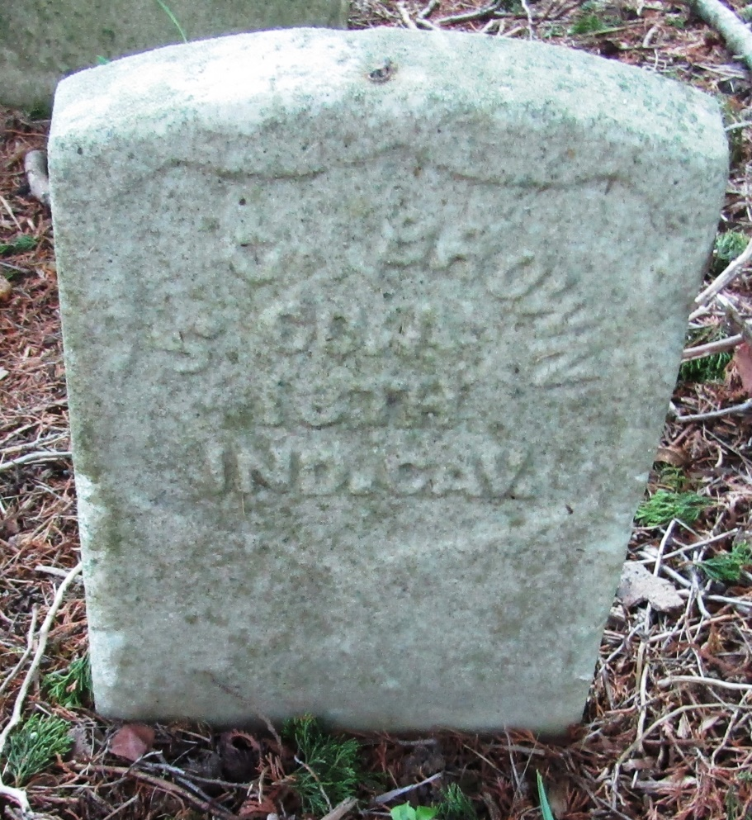

No further information found at this time

