Ell Dora (Wiley) Brineman
June 24, 1886 – June 17, 1944

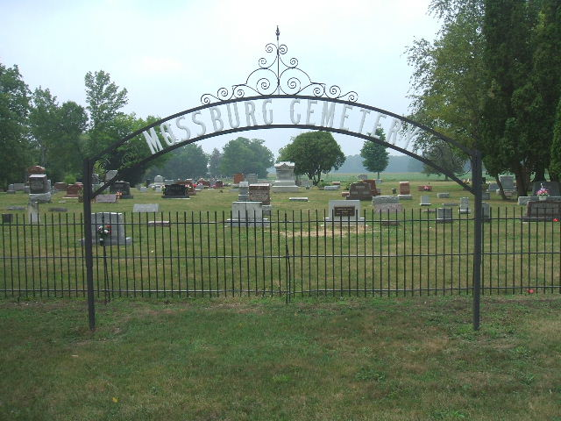

Ell Dora Brinneman
in the Indiana, Death Certificates, 1899-2011
Name: Ell Dora Brinneman
[Ell Dora Wiley]
Gender: Female
Race: White
Age: 57
Marital status: Married
Birth Date: 24 Jun 1886
Birth Place: Wells Co Ind
Death Date: 17 Jun 1944
Death Place: Rural, Wells, Indiana , USA
Father: John Wiley
Mother: Nancy Day
Spouse: Oscar Brinneman
Informant: Oscar Brinneman; Bluffton, Indiana
Burial: June 20, 1944; Mossburg Cemetery

