Arena (Gaskill) Braner
April 9, 1865 – September 22, 1925

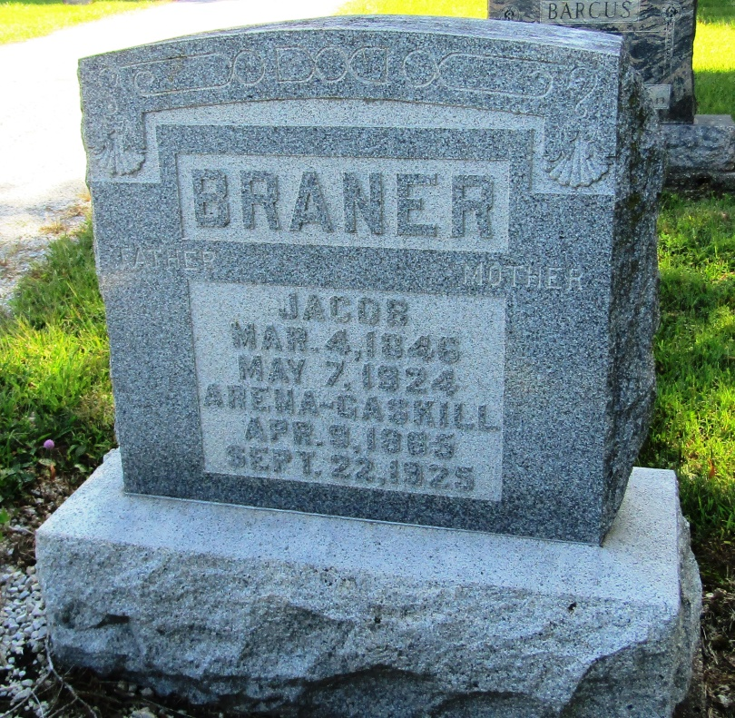

Mrs Arena Brauer
in the Indiana, Death Certificates, 1899-2011
Name: Mrs Arena Braner
[Mrs Arena Gaskill]
Gender: Female
Race: White
Age: 61
Marital status: Widow
Birth Date: 9 Apr 1864
Birth Place: Wells Co Ind
Death Date: 22 Sep 1925
Death Place: Bluffton, Wells, Indiana, USA
Father: Saml Gaskill
Mother: Kathrine Glass
Spouse: John Braner
Burial: Sept. 24, 1925; Mossburg Cem.

