Ava Lou (Ware) Boltin
April 3, 1871 – March 14, 1961

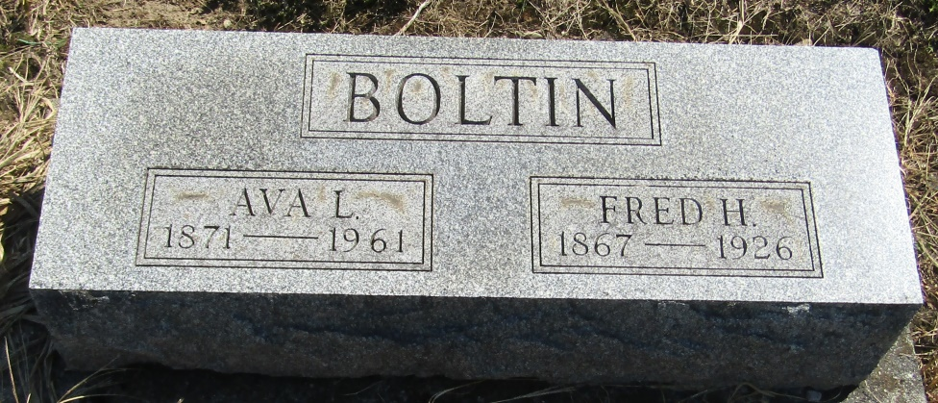

Ana Lou Boltin
in the Indiana, Death Certificates, 1899-2011
Name: Ava Lou Boltin
[Ava Lou Boltin ]
[Ana Lou Ware]
Gender: Female
Race: White
Age: 89
Marital status: Widowed
Birth Date: 3 Apr 1871
Birth Place: Indiana
Death Date: 14 Mar 1961
Death Place: Bluffton, Wells, Indiana, USA
Father: James Ware
Mother: Mary Good
Informant: Mrs. Esther Penrod; daughter; Liberty Center, Indiana
Burial: March 17, 1961; Mossburg Cemetery; Wells County, Indiana

