Marion C. Bohr
January 18, 1886 – July 23, 1961

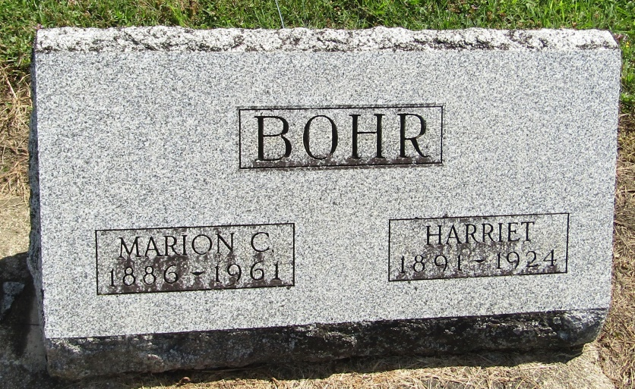

Marion C Bohr
in the Indiana, Death Certificates, 1899-2011
Name: Marion C Bohr
Gender: Male
Race: White
Age: 75
Marital status: Widowed
Birth Date: 18 Jan 1886
Birth Place: Indiana
Death Date: 23 Jul 1961
Death Place: Bluffton, Wells, Indiana, USA
Father: Edward Bohr
Mother: Catherine Darr
Informant: John Bohr; son; Bluffton, Indiana
Burial: July 25, 1961; Mossburg Cemetery; Wells County, Indiana

