John Edward Bohr, Sr.
July 25, 1908 – July 12, 1987

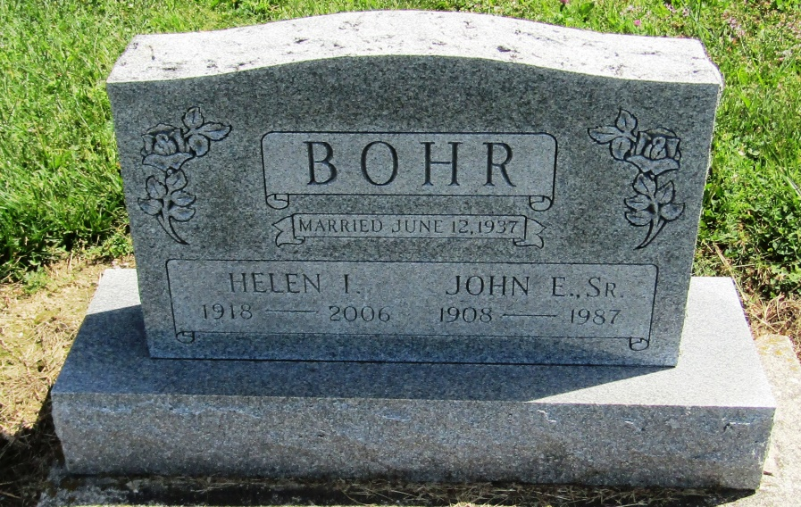

John E Bohr Sr
in the Michigan, Death Index, 1971-1996
Name: John E Bohr Sr
Birth Date: 25 Jul 1908
Death Date: 12 Jul 1987
Gender: Male
Residence: Bainbridge, Berrien, Michigan
Place of Death: Benton Harbor, Berrien, Michigan

